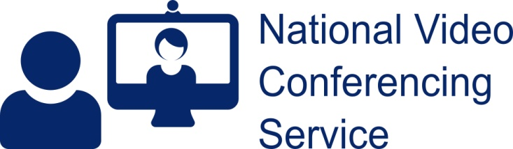  Group Name: Introduction to Pain Management  Attending your group session by video:  Visit www.cms.vc.scot.nhs.uk | Email:  nhsh.wh-pain@nhs.scot  Telephone: 01631 567500

NVCS: Digital Group Sessions

What is a Digital Group Session?
Digital Group Sessions provide an easy and secure way for patients to meet their health care team. They also allow people to meet other patients who have the same issues but without having to meet them physically.
Anyone can attend a Digital Group Session wherever they are if they have a suitable device and access to the internet.

What do I need to take part?
- PC, laptop, tablet or smartphone.
- Good connection to the internet, preferably not using cellular data.
- Recent versions of Chrome, Safari, Firefox or Edge. N.B. iPhones/iPads must use Safari (not Chrome), and since the beginning of May 2021 they must be running iOS v13 or higher. Internet Explorer will not work.
- Invitation details for the Group Session.

How does it work?
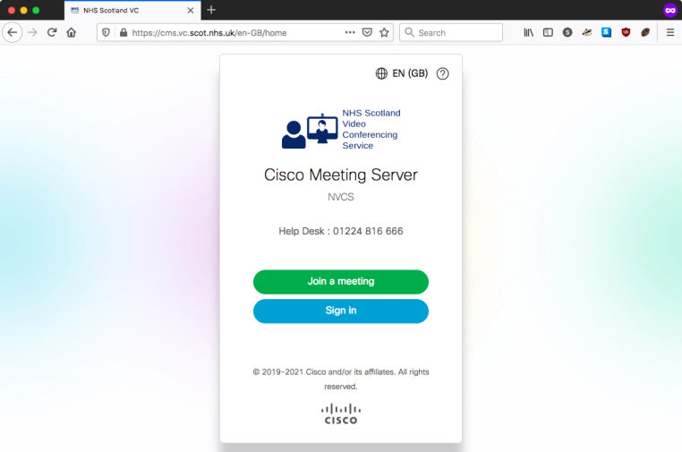 | Go to: https://cms.vc.scot.nhs.uk  Choose the Join a Meeting button  (As only essential cookies are set there are no cookie option notices to deal with)
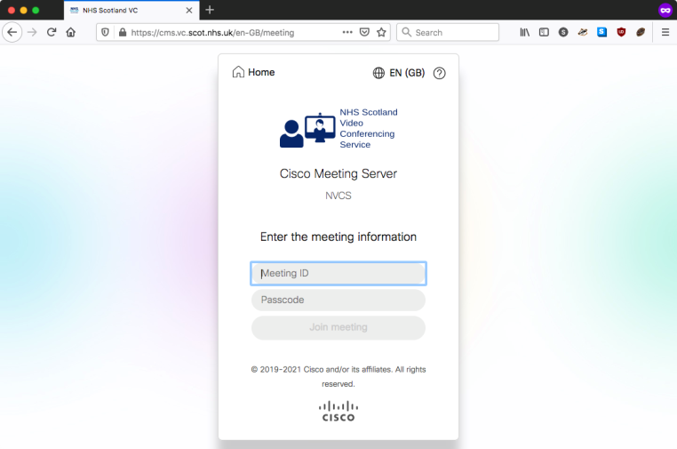 | Enter the Meeting ID then Passcode  Click the Join Meeting button  Accept any messages to allow the use of microphone, camera and speakers
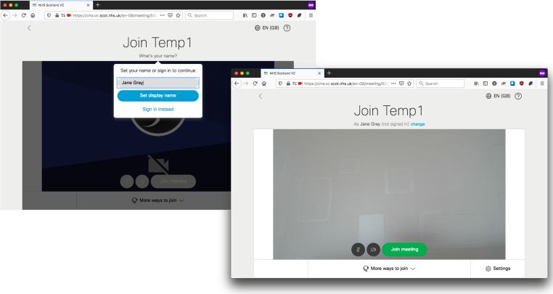 | You’ll see the name of the meeting you’re about to join  Enter a name: it will be displayed to other callers.  Click the Set Display Name button. Ignore the bits about signing in.  You’ll see a self-view.  Use the Join meeting button to enter the video conference.

The URL and Meeting ID for a Group Session are the same for all participants. Staff/clinicians/facilitators use a ‘Host’ Passcode/PIN number. Patients have a ‘Guest’ Passcode/PIN number. The only difference is in the permissions granted.

What happens during a group session?
- Patients wait in the virtual lobby on their own until your health care team member (the host) joins you, or you come into the session immediately if a host has already joined.
- Should all hosts be disconnected, patients will be placed into a lobby on their own until a host re-joins.
- It is possible to join from a telephone (audio only) by calling 01224667661, then providing Meeting ID followed by Passcode/PIN
- Everyone in the session can view how many participants are in attendance and the name participants used when they joined the session
- All attendees have the option to change their layout on screen

In-call controls
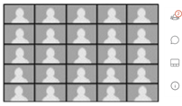  Screen View  The number of callers on screen is device and bandwidth specific. 25 at any one time is the maximum. | Right Hand Side Controls  Click to open tabs of:  Participant list  Chat (if enabled)  Screen Layouts  Information. |  | 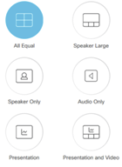  Screen Layout  All participants can choose and change their own layout for their screen during the session. Hosts can’t set this for others, only advise e.g. Speaker large if giving a presentation.

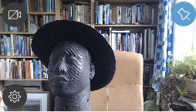  Camera control  When joining a call you’ll see a self-view at the bottom LHS (wiggle your mouse or tap your screen if it’s hidden, which it does after a few seconds).  The pin icon allows you to keep your self-view on.  Use the cog icon for camera/mic/speaker options.  The camera icon can mute/unmute your camera. | Standard call controls  At the bottom of your call screen are the normal call controls allowing microphone muting. Use the red X button to end your call. If they’ve become hidden, wiggle your mouse/tap your screen to see them.

Notes
- No data is stored by the platform.
- No chat is stored, even between sessions. If you drop out and re-join, you will not see past chat.
- Recording is not possible on the platform
- All participants choose the name they use to join the session so can join anonymously if required.

